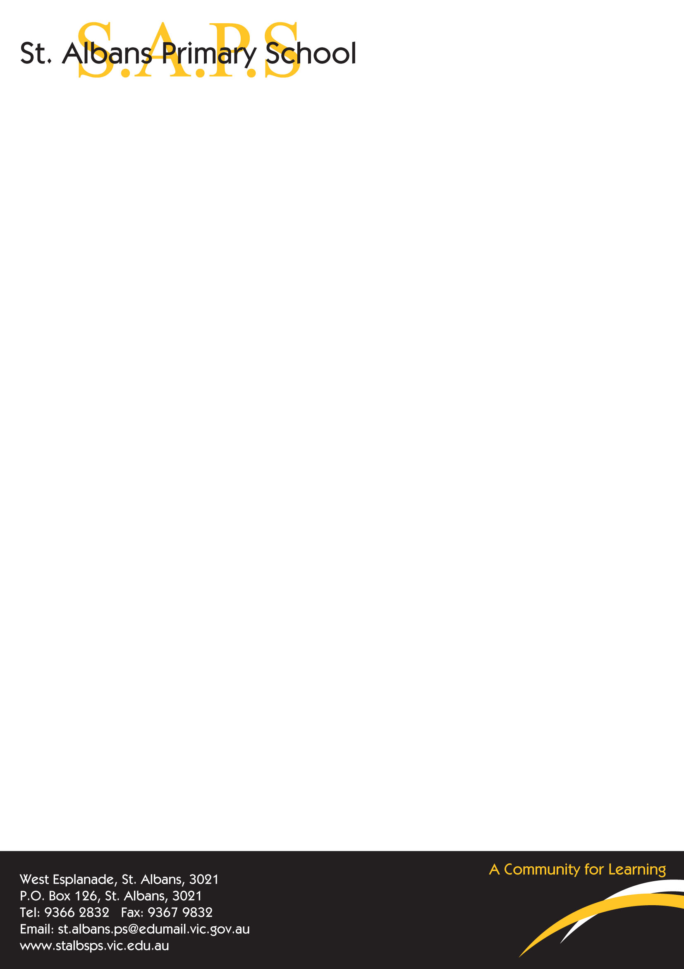

Uniform Price List and Order Form 2025

Student Name: ___________________________ Class: ________________

Item | Price | Size | Quantity | Total Cost
Track pants (straight leg)  Sizes 4-16 | $20.00
Dress  Sizes 5-16 | $50.00
Windcheater  Sizes 4-18 | $25.00
Bomber Jacket  Sizes 4-18 | $40.00
Polo Shirt – Short Sleeve  Sizes 4-20 | $25.00
Polo Shirt – Long Sleeve  Sizes 4-20 | $25.00
Shorts  Sizes 6-16 | $20.00
Winter Tunic  Sizes 4-16 | $50.00
Hats  Broad brimmed  Sml, Med, Large | $10.00
TOTAL COST |  |  |  | $

Orders can be placed at the office if correct money is placed in an envelope along with this completed order form.
Please be aware that the sizes of the uniforms are smaller than they appear. If you require a bigger size than the sizes listed above this may take a few weeks to be delivered.

Prices and products may change.
Prices may increase due to increases by suppliers.

